TRENDS TOWARDS PARALLEL PROCESSING
From an application point of view, mainstream usage of computers is experiencing a trend of four ascending order of sophistication. The relationship between data, information, knowledge and intelligence are demonstrated in fig 1.2.
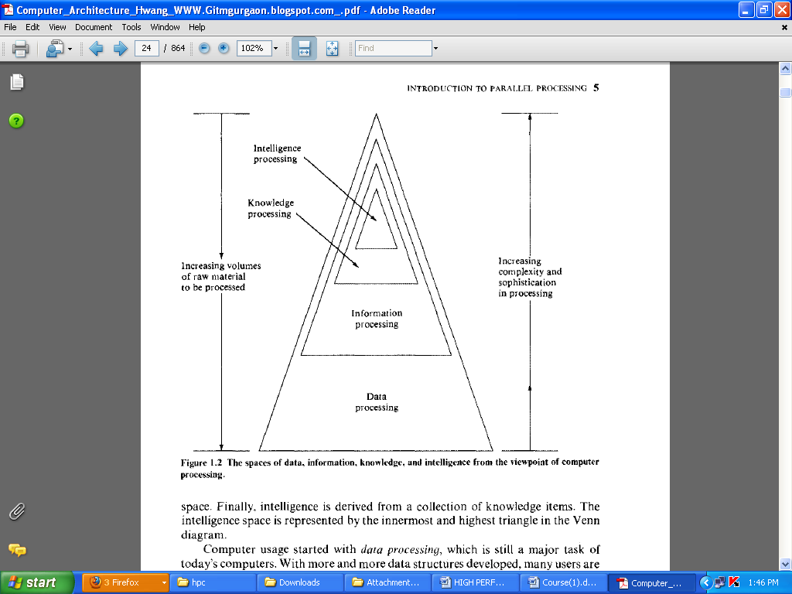
- Data processing
Computer usage started with data processing, which is still a major task of today’s computers. With more and more data structures developed, many users are shifting to computer roles from pure data processing to information processing. Data space is the largest, including numeric numbers in various formats, character symbols, and multidimensional measures
- Information processing
An information item is a collection of data objects that are related by some syntactic structure. Therefore information items form a subspace of data space.
- Knowledge processing
Most of today’s computing is still confined within these data processing and information processing. A high degree of parallelism has been found at these levels. As the accumulated knowledge bases expanded rapidly in recent years, there grew a strong demand to use computers for knowledge processing
- Intelligence processing
Today’s computers can be made very knowledgeable but are far from being intelligent .Intelligence is very difficult to create; it’s processing even more so. The degree of parallelism exploitable at the two highest processing levels should be higher than that at the data-information processing levels.
Definition for parallel processing
Parallel processing is an efficient form of information processing which emphasizes the exploitation of concurrent events in the computing process. Concurrently implies parallelism, simultaneity, and pipelining. Parallel events may occur in multiple resources during the same time interval; simultaneous events may occur at the same time instant; and pipelined events may occur in overlapped time spans.
Parallel processing can be challenged in four programmatic levels:
- Job or program level
- Conducted through multiprogramming , time sharing and multiprocessing.
- Requires parallel processing algorithms.ie, mainly implemented in software.
- Task or procedure level
- Involves the decomposition of a program into multiple task
- Interinstruction level
- Exploit concurrency among multiple instructions
- Data dependency analysis should be conducted to reveal parallelism
- Intrainstruction level
- Intra-Instruction parallelism is based on the observation that each instruction goes through a similar set of mutually exclusive phases
- Often implemented directly by hardware means

What is Parallel Computing?
- Traditionally, software has been written for serial computation:
  - To be run on a single computer having a single Central Processing Unit (CPU);
  - A problem is broken into a discrete series of instructions.
  - Instructions are executed one after another.
  - Only one instruction may execute at any moment in time.
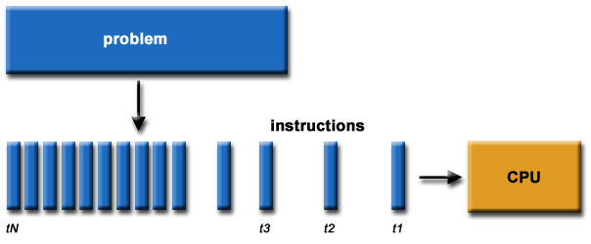
- In the simplest sense, parallel computing is the simultaneous use of multiple compute resources to solve a computational problem:
  - To be run using multiple CPUs
  - A problem is broken into discrete parts that can be solved concurrently
  - Each part is further broken down to a series of instructions
  - Instructions from each part execute simultaneously on different CPUs
